**Jahangirnagar University**

**Department of Computer Science & Engineering**



**Course Code**: CSE-402

**Course Title**: Computer Networking Laboratory

**Submitted by**:

**Name**: Md Shamim Imtiaz

**Roll No**: 47

**Date of Submission**: 5th September, 2019

**Experiment No: 02**

**Experiment Name:** Packet through router.

**Introduction:**

In this experiment we will configure routers in between some networks to connect to further network via routing table where network and hop will be mentioned. When sending a packet this routers will recognize which hop to jump to send a packet.

**Description:**

We used cisco packet tracer for simulation. Several computer devices are connected through the routers and different IP addresses were assigned to them. Then a packet is sent through them to check the characteristics of routers we created a hop table to access networks that are far from the routers to pass the packets.

**Simulation:**

**Router:**

Routers are small electronic devices that join multiple computer networks together using either wired or wireless connections. In technical terms, a router is a Layer 3 network gate way device, meaning that it connects two or more networks and that the router operates at the network layer of the OSI model.

1. **One Router:**

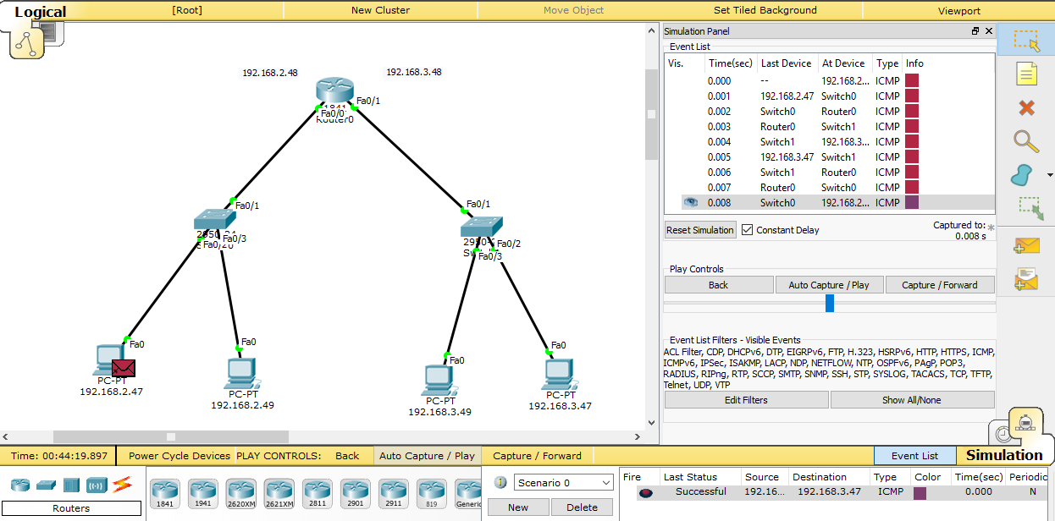

1. **Multiple Router:**

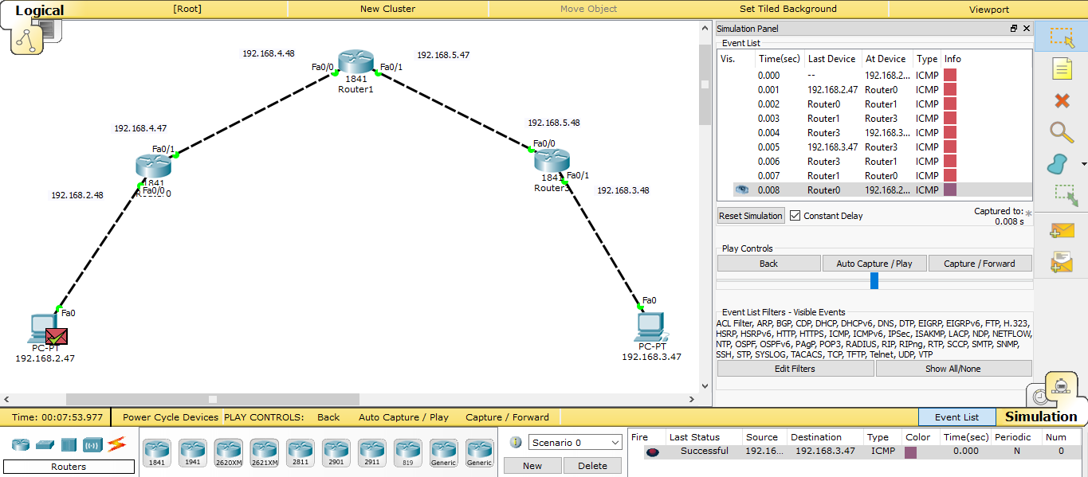

1. **Multiple Router and Hub:**

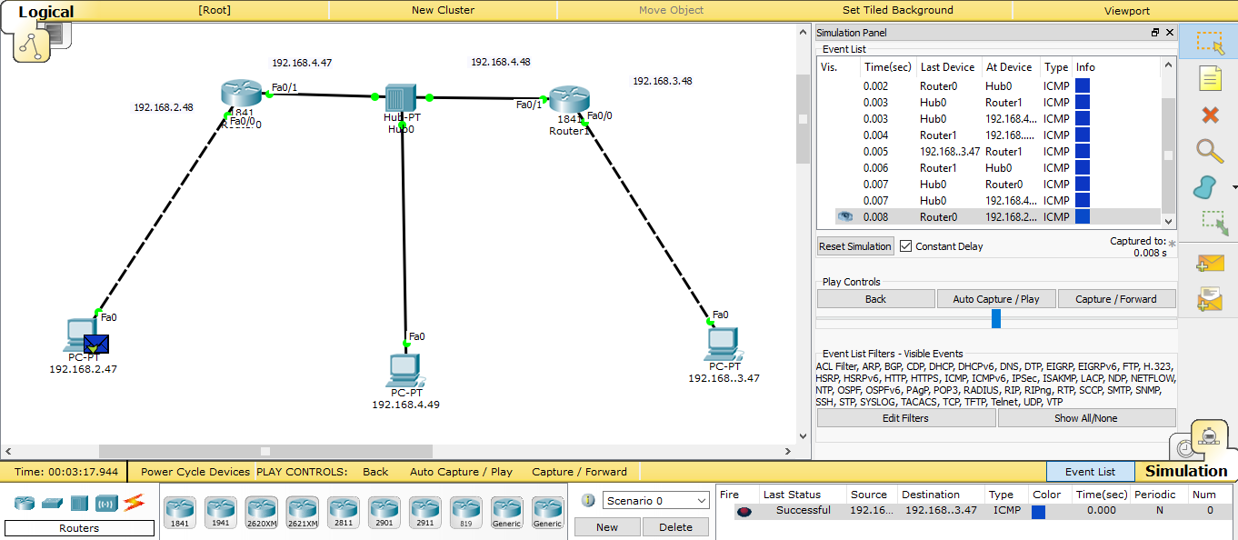

**Discussion:**

We can see that the Routers sends the packet the required path mentioned in the rout table. People tend to get benefit from a router for through a packet to a different network. A router is better for connecting different network. After using router we can easily use hub, switch, PC for any other connection and for any other communication.